./

Learning Report – LIBRARY MANAGEMENT SYSTEM

Course Code: <CODE>



|  |  |  |  |  |  |
| --- | --- | --- | --- | --- | --- |
| **Ver. Rel. No.** | **Release Date** | **Prepared. By** | **Reviewed By** | **Approved By** | **Remarks/Revision Details** |
|  |  |  |  |  |  |
|  |  |  |  |  |  |
|  |  |  |  |  |  |
|  |  |  |  |  |  |
|  |  |  |  |  |  |

**Document History**

# 

Contents

Checklist 3

Activity and Tasks 4

**Activity 1**– System/Software Development 4

**Activity 2** –CI Workflow for C Programming 4

**Activity 3** – Agile Aspects 4

# Checklist

* Installation of SW on Phone and Desktop
* Additional Aspects …

# Activity and Tasks

## **Activity 1**– System/Software Development

* Sub Tasks
* Complete and Evolve

## **Activity 2** –CI Workflow for C Programming

* Sub Tasks
* Complete and Evolve

## **Activity 3** – Agile Aspects

* …..

**TABLE OF CONTENTS**

PageNo

1. BACKGROUND…………………………………………………………………….. 7
2. REQUIREMENTS……………………………………………………………………. 8
   1. High-Level Requirements………………………………………………………….
   2. Low-Level Requirements……………………………………………………….....
3. ARCHITECTURE……………………………………………………………………. 9-11

3.1 Behavioral Diagrams………………………………………………………………

3.2 Structural Diagrams………………………………………………………………..

1. TESTPLAN……………………………………………………………………………. 12
2. REFERENCES……………………………………………………………………….... 13

**LIST OF FIGURES**

|  |  |  |
| --- | --- | --- |
| SINo | FigName | PageNo |
| 1. | Use case Diagram for Library Management System | 8 |
| 2. | Activity Diagram for Library Management System | 9 |
| 3. | Class Diagram for Library Management System | 10 |

**LIBRARY MANAGEMENT SYSTEM**

1. **BACKGROUND**

The Library Management System is an online application for assisting a librarian in managing a book library in a University. The system would provide basic set of features to add/update clients, add/update books, search for books, and manage check-in / checkout processes. Our test group tested the system based on the requirement specification.

**SYSTEM ANALYSIS**

**EXISTING SYSTEM**

In our existing-system all the transactions are done manually. So taking more time for transaction like borrowing a book or returning a book and also for searching of members and book. Another major advantage is that to preparing the list of books borrowed and the available books in the library will take more time, currently it is doing as a one day process for verifying all records.

**PROPOSED SYSTEM**

Proposed system is an automated library management system. Through our software users can add members, search book, update information, edit information, borrow and return books in quick time.

1. **REQUIREMENTS**

2.1 HIGH LEVEL REQUIEMENTS

* Main menu
* Issue Books
* Add Books
* Search Books
* Delete Books
* View book list

2.2 LOW LEVEL REQUIEMENTS

* Development Environment- Code Blocks
* Operating System-Windows 7/10
* Programming Language-C
* Ram-1GB(minimum),2Gb or above(Recommended)
* Hard Disk-128GB or above
* Processor -Intel Premium IV or above

|  |  |
| --- | --- |
| **ID** | **DESCRIPTION** |
| HL_01 | Main menu is used to display the main menu of this project like Issue books, add books, search books, delete books. |
| HL_02 | Issue books request for issuing a specific book. |
| HL_03 | Add Books to add new category book which is available. |
| HL_04 | Delete books deletes books in a file. For that, you need to mention the department to which you want to add the book. |
| HL_05 | View book list lists all the books for each department. |
| LL_01 | The Development Environment is Code-blocks. |
| LL_02 | The Operating System can be Windows 7/10. |
| LL_03 | The programming language used is C. |
| LL_04 | Ram can be of 1GB(minimum),2GB or above. |
| LL_05 | The Hard Disk of 128GB or above is used. |
| LL_06 | Intel Premium IV or above processor is used. |

1. **ARCHITECTURE**

**3.1 Behavioral Diagrams**

1. **USECASE DIAGRAM**

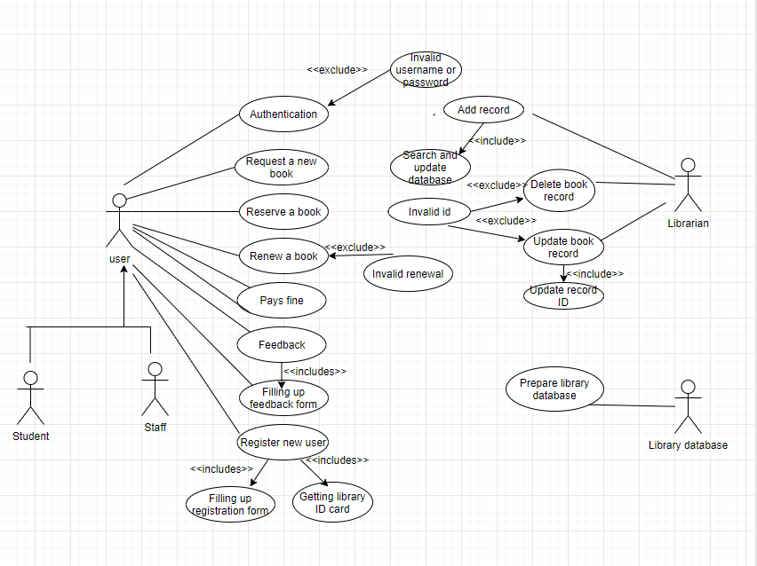

* + 1. **Use case diagram**

**ACTIVITY DIAGRAM**

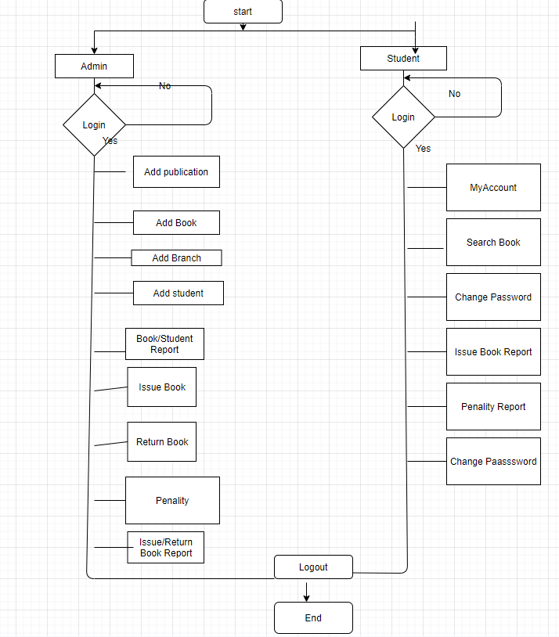

* + 1. **Activity Diagram**

**3.2 STRUCTURAL DIAGRAMS**

1. **Class Diagram**

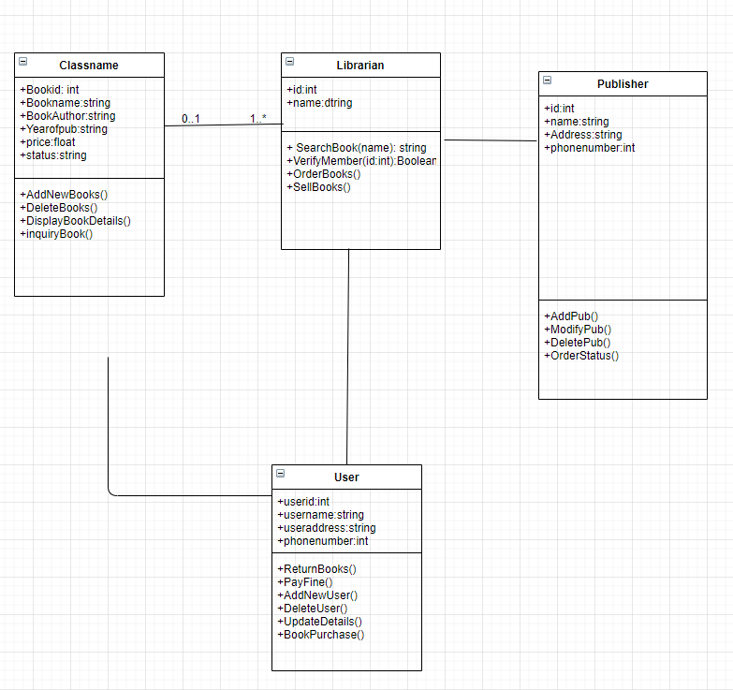

* + 1. **Class Diagram**

1. **TEST PLAN**

Test for the admin module

1. Testing admin login form:

This form is used for login of administrator of the system. In this we enter the username and password if both are correct administration page will be opened other-wise if any of the data is wrong it will get redirected back to the login page and again ask for username and password.

1. Student account addition:

In this section admin can verify the student details from student academic info and then only add student details to main library database it contains add and delete buttons if user click add button data will be added to student database and if he clicks delete button student data will be deleted.

1. Book addition

Admin can enter the details of the book and can add the details to the main book table also he can view the book requests.

Test for Student Login module

1. Test for student login form

This is used for login of the student. In this we enter the library id, username and password if all these are correct student login will open otherwise if any of the data is wrong it will get redirected to the login page and again ask for library id, username and password.

1. Test for account creation

This form is used for new account creation when student does not fill form completely it asks again to fill the whole form when he fill the form full gets redirected to page which show waiting for confirmation message as his data will be only added by administrator after verification .

**References**

<https://ampletrails.com/library-management-system/>

<https://en.wikipedia.org/wiki/Library_management>

<https://www.startertutorials.com/uml/resources/lms/LMS6.pdf>

<https://preplibs.wordpress.com/library-management-systems/>